Name: _____________________________ Date: ____________________ Period: _____

Mitosis, Meiosis & Cancer Review Sheet

- Distinguish between diploid & haploid cells.

2. If an organism’s diploid number is 8, what is its haploid number?

3. What process results in the production of gametes?

4. What is crossing-over?

5. Why is meiosis often referred to as “reduction division”?

6. Are the cells produced by mitosis haploid or diploid?

7. Are the cells produced by meiosis haploid or diploid?

8. Why do cells divide rather than continue to grow larger?

10. What is the cell cycle?

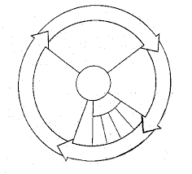
11. Label the cell cycle diagram
12. Duplicated chromosomes consist of 2 sister chromatids. What is the name of the structure
that connects the chromatids together?

13. Identify the process cells use to repair damaged/injured tissue.
14. Compare mitosis & meiosis by completing the following chart:

 | Mitosis | Meiosis
Type of cells produced
# of divisions
Chromosome #
DNA replication
Crossing Over
# of cells produced
Daughter cells in relation to parent cell

15. What is cancer?

16. Distinguish between a benign tumor and a malignant tumor.

17. Identify three causes of cancer.

18. Describe 3 treatments for cancer.

Bonus: One discussion question from the Cancer Warrior will be included (+3 bonus points)

